[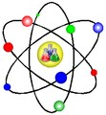](https://www.google.co.uk/url?sa=i&rct=j&q&esrc=s&source=images&cd&cad=rja&uact=8&ved=0ahUKEwi7tfO_nMDNAhUpJcAKHdUxAJ8QjRwIBw&url=https%3A//answers.yahoo.com/question/index%3Fqid%3D20130301131537AA5pH2k&bvm=bv.125221236%2Cd.ZGg&psig=AFQjCNFfZSzd4eozOnSrXhvSTxtVBxVtbg&ust=1466842551691684)**GCSE to A Level Chemistry Transition Guide**

## Why study A-level Chemistry?

Chemistry students get to investigate all sorts of ideas: the big question

you’ll ask yourself is ‘what is the world made of?’ If you choose it as career; you have the potential to help solve all sorts of problems. You could work on a cure for cancer, or you might develop a new food: the possibilities are endless.

Even if you don’t decide to work in chemistry, studying it still develops useful and transferable skills for other careers. You’ll develop research, problem solving and analytical skills, alongside teamwork and communication. Universities and business regard all of these very highly.

## Possible degree and career options:

According to bestcourse4me.com, the top five degree courses taken by students who have A-level Chemistry are:

* Chemistry
* Biology
* Medicine
* Mathematics
* Pharmacology.

## Studying Chemistry at A-level or degree opens up all sorts of career opportunities.

* Analytical chemist
* Chemical engineer
* Clinical biochemist
* Pharmacologist
* Doctor
* Research scientist (physical sciences)
* Toxicologist
* Environmental consultant
* Higher education lecturer or secondary school teacher
* Patent attorney
* Science writer.

**Specification at a glance**

|  |  |  |
| --- | --- | --- |
| AS and A- level | | |
| **Physical chemistry** | **Inorganic chemistry** | **Organic chemistry** |
| * Atomic structure * Amount of substance * Bonding * Energetics * Kinetics * Chemical equilibria, Le   Chatelier’s principle and Kc   * Oxidation, reduction and   redox equations | * Periodicity * Group 2, the alkaline earth   metals   * Group 7(17), the halogens | * Introduction to organic chemistry * Alkanes * Halogenoalkanes * Alkenes * Alcohols * Organic analysis |
| A-level only topics | | |
| **Physical chemistry** | **Inorganic chemistry** | **Organic chemistry** |
| * Thermodynamics * Rate equations * Equilibrium constant Kp for   homogeneous systems   * Electrode potentials and   electrochemical cells   * Acids and bases | * Properties of Period 3 elements and oxides * Transition metals * Reactions of ions in aqueous   solution | * Optical isomerism * Aldehydes and ketones * Carboxylic acids and   derivatives   * Aromatic chemistry * Amines * Polymers * Amino acids, proteins and   DNA   * Organic synthesis * NMR spectroscopy * Chromatography |

[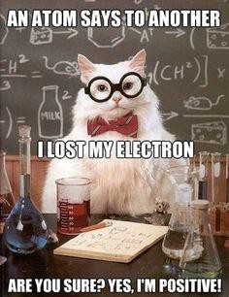](https://www.google.co.uk/url?sa=i&rct=j&q&esrc=s&source=images&cd&cad=rja&uact=8&ved=0ahUKEwif57WXnMDNAhVLL8AKHVe1ATsQjRwIBw&url=https%3A//www.steamgifts.com/discussion/1CNxc/chemistry-jokes&psig=AFQjCNFOpvRRqvSeLDdbot2_fau4TdABLw&ust=1466842427234272)

**The assessment for the A level consists of three exams:**

|  |  |  |  |  |
| --- | --- | --- | --- | --- |
| Paper 1 | + | Paper 2 | + | Paper 3 |
| What's assessed   * Relevant Physical   chemistry topics (sections   * + 1. to 3.1.4, 3.1.6 to 3.1.8   and 3.1.10 to 3.1.12)   * + - * Inorganic chemistry   (Section 3.2)   * + - * Relevant practical skills | What's assessed   * Relevant Physical   chemistry topics (sections 3.1.2 to 3.1.6 and 3.1.9)   * Organic chemistry   (Section 3.3)   * Relevant practical skills | What's assessed   * Any content * Any practical skills |
| How it’s assessed   * written exam: 2 hours * 105 marks * 35% of A-level | How it’s assessed   * written exam: 2 hours * 105 marks * 35% of A-level | How it’s assessed   * written exam: 2 hours * 90 marks * 30% of A-level |
| Questions  105 marks of short and long answer questions | Questions  105 marks of short and long answer questions | Questions  40 marks of questions on practical techniques and data analysis  20 marks of questions testing across the specification  30 marks of multiple choice questions |

**To help you during the course:**

* 1. Mrs Marshall, Mrs Sinclair, Mrs Higgins, Mrs Swain and Dr Randerson are all on hand to help if you have any questions or worries before or during the course.
  2. The AQA website is very helpful and although aimed at teachers includes:
     1. The specification – this explains exactly what you need to learn for your exams.
     2. Practice exam papers
     3. Lists of command words and subject specific vocabulary – so you understand the words to use in exams
     4. Practical handbooks explain the practical work you need to know
     5. Past papers from the old specification. Some questions won’t be relevant to the new AS

and A-level so please check with your teacher.

* + 1. Maths skills support. Web resources page with many links to other resources to support study.
  1. [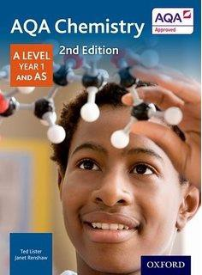](https://www.google.co.uk/url?sa=i&rct=j&q&esrc=s&source=images&cd&cad=rja&uact=8&ved=0ahUKEwiahO2Ltb7NAhXmB8AKHWxcCuQQjRwIBw&url=https%3A//www.amazon.co.uk/Level-Chemistry-Student-level-Science/dp/1471807673&psig=AFQjCNFv94ACE1jSLuYUYjK-6Xou1hJ2Qw&ust=1466780439931474)Text books: We recommend the Oxford text book, AQA Chemistry A Level Year 1 and AS by Ted Lister and Janet Renshaw, the ISBN is 978- 0-19-835181-8.

There is a 2 year version available, cheaper in the long run if you do AS and A level but a bigger investment to start with. You will need to purchase a copy of this book when you start the course, but you can of course buy it over the summer if you wish.

* 1. Revision guides - These are great if you want a quick overview of the

course when you’re revising for your exams. Remember to use other tools as well, as these aren’t detailed enough on their own. Many current and previous students like the CGP one but there are others on the market and are not compulsory.

* 1. The Royal Society of Chemistry (RSC), the RSC do everything from naming new elements and lobbying MPs, to improving funding for research sciences in the UK. You’ll find lots of handy resources on their website.
  2. The student room, join the A-level Chemistry forums and share thoughts and idea with other students if you’re stuck with your homework. Just be very careful not to share any details about your assessments, there are serious consequences if you’re caught cheating. Visit thestudentroom.co.uk
  3. Youtube has thousands of Chemistry videos. Just be careful to look at who produced the video and why because some videos distort the facts. Check the author, date and comments – these help indicate whether the clip is reliable. If in doubt, ask your teacher.
  4. Magazines: Focus, New Scientist or Philip Allan updates can help you put the chemistry you’re

learning in context.

**Summer Transition Work**

* The transition to A level chemistry from GCSE is steep. Although your work over the last 5 years will have given you some foundations for your new course, we build upon them quickly. To ensure you get off to the best start you need to ensure your foundations are secure and you have a good understanding of all aspects of GCSE chemistry and do not forget it all over the summer.
* Please see below for your summer transition work to help you make a positive start to year 12 which is due in on **Monday 23rd September 2024.**
* **Please print (p5-14) and complete the booklet. Space has been left to attach your timeline.**

# Task 1- Common Ions to learn

You can expect to be tested on these in the first few weeks of September.

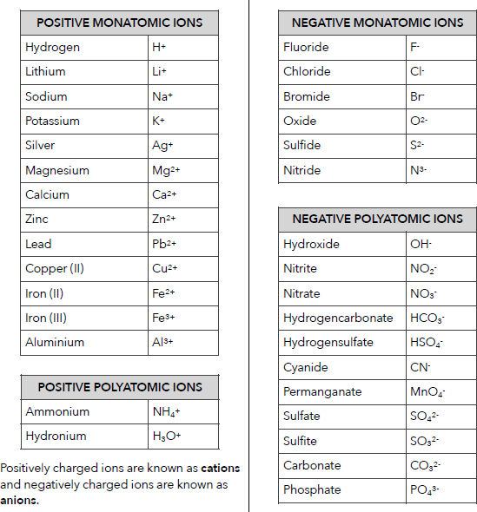

# Task 2- Ionic formulae

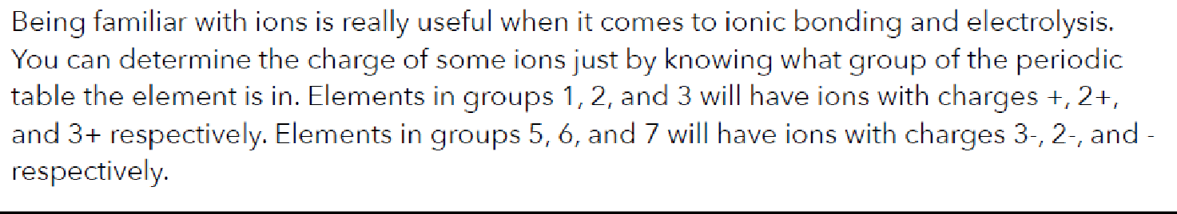

**Use the charges and the rules above to work out the formulae of the following compounds:**

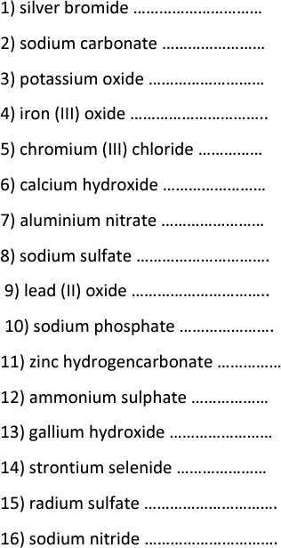

# Task 3- Balancing equations

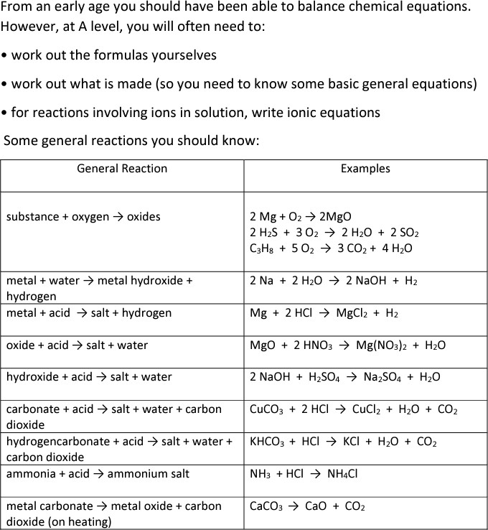

**Learn the word equations (in the above table) for the general reactions.**

# Task 4- Atomic history

Please watch the documentary below on the discovery of the atom and create a **detailed timeline** of the scientific breakthroughs which have led to the modern atomic model we use today.



# Task 5- Atomic Structure

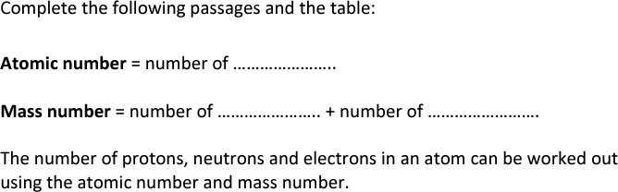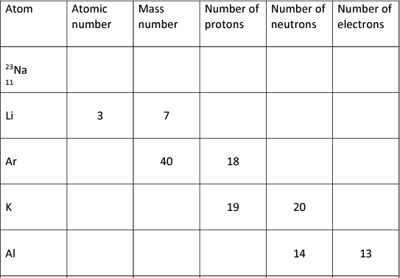

**Task 6- Calculating Relative Formula Mass (Mr)**

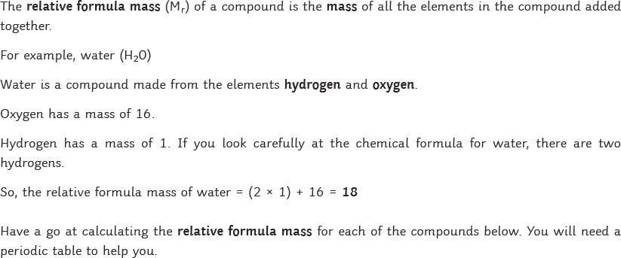

|  |  |  |  |
| --- | --- | --- | --- |
|  | Calculate tne M, for eacn of tne compounds below. | Use tnis space to snow your working out. | Write your answer in tne box below. |
| 1 | Sr(OH)z |  |  |
| 2 | SrC03 |  |  |
| 3 | Na2Se03 |  |  |
| 4 | Na2Mn04 |  |  |
| 5 | Cu(N3)z |  |  |
| 6 | NaHC03 |  |  |

**Task 7**

Complete the summary table for the key types of structures and bonding from GCSE.

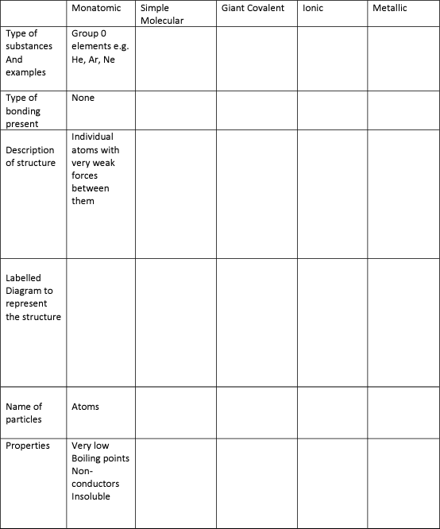

**Task 8**

Complete the naming and dot/cross covalent bonding diagrams below.

