Year 12 Practical Summer Work

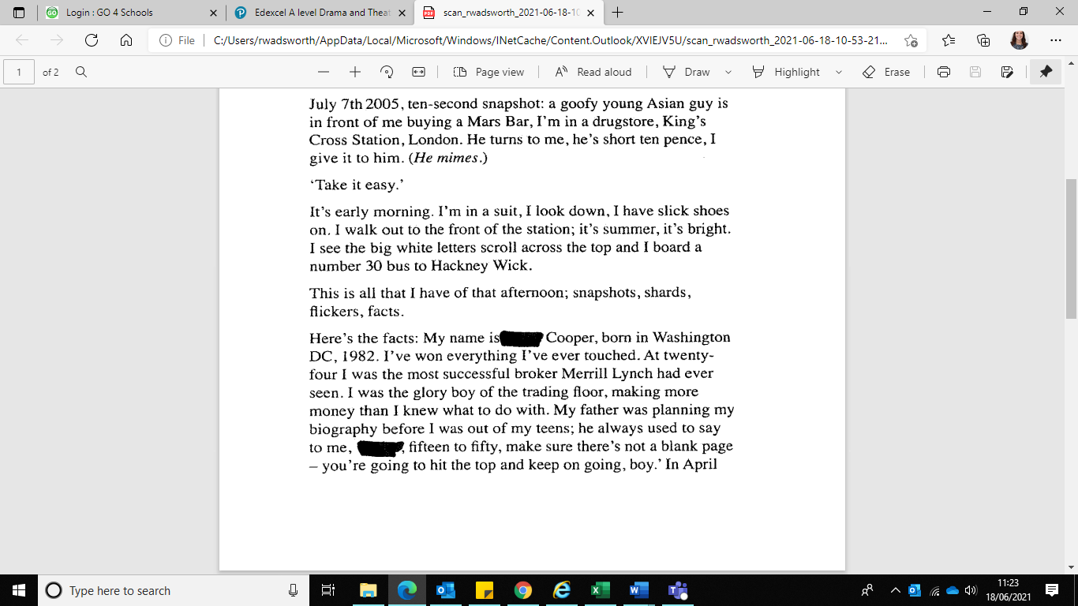

Present the monologue below in a style of your choice. You must learn the monologue, it is not acceptable to read it. You will be assessed on the way you use vocal and movement skills and should therefore ensure that you use both equally. This must be a finished performance.

Areas to consider:

-Naturalism, non-naturalism or both

-Character

- Concept/Theme

You must be ready to perform this in your first lesson in September

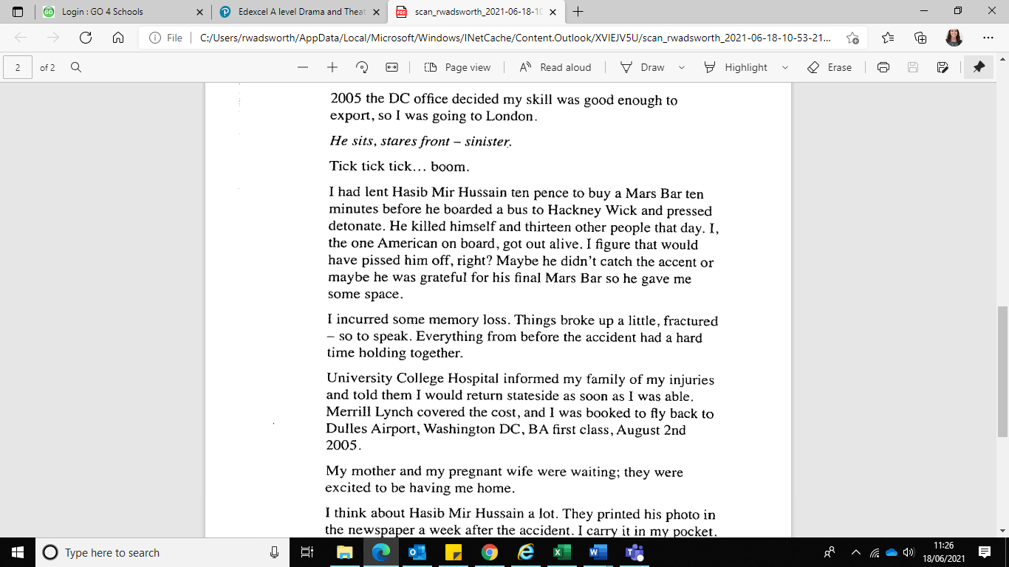

About you!

**Please complete the questions below and bring to your first lesson:**

**Where did you do your GCSE’s? __________________________________________________**

**___________________________________________________________________________**

**Explain what Drama was like at your school. Give reference to texts studies, performances you did ___________________________________________________________________________**

**Why did you decide to take RSL Acting? ___________________________________________**

**___________________________________________________________________________**

**___________________________________________________________________________**

**What performance experience have you had? _______________________________________**

**___________________________________________________________________________**

**___________________________________________________________________________**

**Which actors inspire you and why? _______________________________________________**

**___________________________________________________________________________**

**___________________________________________________________________________**

**What is the last piece of theatre you have seen (live or digital)? _______________________**

**___________________________________________________________________________**

**___________________________________________________________________________**

**What are you looking forward to the most about this course? __________________________**

**___________________________________________________________________________**

**___________________________________________________________________________**

Throughout the course you will be expected to help with extra curricular clubs within Performing Arts. In preparation we would like **you to lead one drama game** to the rest of the class in September this will help in getting to the know class.

Have fun 😊