

Spanish A Level

Transition Booklet 2024

The Arthur Terry School

This booklet has been prepared by MFL staff for you to read and the suggested activities contained in it will ensure that you get off to the best possible start in this subject area. It is very important that you read this booklet carefully over the summer. This will give you a clear understanding of what the course involves and what to expect next year.

Exam board: AQA

Paper 1: Listening, Reading & Writing (50%)

Paper 2: Writing (Film/Novel) (20%)

Paper 3: Speaking (30%)

Course Specification: <http://filestore.aqa.org.uk/resources/spanish/specifications/AQA-7692-SP-2016.PDF>

¡Hola a todos! We hope you are all keeping safe and well. We are delighted that you have chosen Spanish for and AS and A level! We have put together some work that will bridge the gap between GCSE and the A level course. There are six parts to this work.

1. Outline of the course content.
2. Cultural research.
3. Grammar and translation.
4. Speaking work.
5. El laberinto del fauno – the set film
6. Useful websites.

Actividad 1: El curso

Read through the list of themes we will study and translate them into English. Use a dictionary to help if you need it.

|  |  |
| --- | --- |
| **Aspects of Hispanic society**  **(in relation to any Spanish-speaking country or countries)** | |
| **Spanish** | **English Translation** |
| **Los valores tradicionales y modernos** | • **Modern and traditional values** |
| *• Los cambios en la familia* |  |
| *• Actitudes hacia el matrimonio/el divorcio* |  |
| *• La influencia de la Iglesia Católica* |  |
| **El ciberespacio** | **• Cyberspace** |
| *• La influencia de internet* |  |
| *• Las redes sociales: beneficios y peligros* |  |
| *• Los móviles inteligentes en nuestra sociedad* |  |
| **La igualdad de los sexos** | • **Equal rights** |
| *• La mujer en el mercado laboral* |  |
| *• El machismo y el feminismo* |  |
| *• Los derechos de los gays y las personas transgénero* |  |

|  |  |
| --- | --- |
| **Artistic culture in the Spanish-speaking world**  **(in relation to any Spanish-speaking country or countries)** | |
| **Spanish** | **English Translation** |
| **La influencia de los ídolos** | **• Modern day idols** |
| *• Cantantes y músicos* |  |
| *• Estrellas de televisión y cine* |  |
| *• Modelos* |  |
| **La identidad regional en España** | **• Spanish regional identity** |
| *• Tradiciones y costumbres* |  |
| *• La gastronomía* |  |
| *• Las lenguas* |  |
| **El patrimonio cultural** | • **Cultural heritage** |
| *• Sitios turísticos y civilizaciones prehispánicas: Machu Picchu, la Alhambra, etc.* |  |
| *• Arte y arquitectura* |  |
| *• El patrimonio musical y su diversidad* |  |

|  |  |
| --- | --- |
| **Multiculturalism in Hispanic society**  **(in relation to any Spanish-speaking country or countries)** | |
| **Spanish** | **English Translation** |
| **La inmigración** | • **Immigration** |
| *• Los beneficios y los aspectos negativos* |  |
| *• La inmigración en el mundo hispánico* |  |
| *• Los indocumentados - problemas* |  |
| **El racismo** | **• Racism** |
| *• Las actitudes racistas y xenófobas* |  |
| *• Las medidas contra el racismo* |  |
| *• La legislación anti-racista* |  |
| **La convivencia** | • **Integration** |
| *• La convivencia de culturas* |  |
| *• La educación* |  |
| *• Las religiones* |  |

|  |  |
| --- | --- |
| **Aspects of political life in the Hispanic World**  **(in relation to any Spanish-speaking country or countries)** | |
| **Spanish** | **English Translation** |
| **Jóvenes de hoy, ciudadanos del mañana** | • **Youth of today, citizens of tomorrow** |
| *• Lo jóvenes y su actitud hacia la política : activismo o apatía* |  |
| *• El paro entre los jóvenes* |  |
| *• Su sociedad idela* |  |
| **Monarquías y dictaduras** | **• Monarchies and Dictatorships** |
| *• La dictadura de Franco* |  |
| *• La evolución de la monarquía en España* |  |
| *• Dictadores en latinoamericanos* |  |
| **Los Movimientos Populares** | • **Popular Movements** |
| *• la efectividad de las manifestaciones y las huelgas* |  |
| *• El poder de los sindicatos* |  |
| *• Ejemplos de protestas sociales* |  |

Actividad 2: Investigación Cultural

The questions below link to the six topics that we study in Year 12. Your research should be completed in English, using the Internet. You should use online encyclopaedias, quality online newspapers and even social media!

1.1 Los valores tradicionales.

1. Who was the dictator of Spain between 1939-1975? What was life like during this period?
2. What was the legal status of divorce, abortion and women’s rights during this period?
3. What is the current rate of divorce in Spain? Choose two further Spanish-speaking countries. Do the results differ? If so, why do you think that is?
4. Which is the main branch of Christianity in Spain? How does this relate to divorce and abortion?

1.2 El ciberespacio.

1. What are some of the main dangers of using the Internet? Make a list of five issues.
2. What percentage of homes in Spain have access to the Internet? Choose two further Spanish-speaking countries. Do the results differ? If so, why do you think that is?
3. How have mobile phones changed over the last twenty years?
4. What are the pros and cons of using modern technology for the elderly?

1.3 La igualdad de los sexos.

1. How has the role of women in the workplace changed in Spain over the last 80 years? Compare this to another Spanish-speaking country.
2. What is “el machismo”? Is this still relevant to Spanish society nowadays?
3. What are the statistics regarding violence against women in Spain? Compare this to another Spanish-speaking country.
4. Make a list of the Spanish-speaking countries that have legalised same sex marriage, including the years in which the law was changed.
5. Which Spanish-speaking countries do not yet recognise same-sex marriage? Why do you think the law hasn’t changed yet?
6. Choose a Spanish speaking country and create a fact file, detailing the rights of LGBTQ people there.

1.4 La influencia de los ídolos.

1. Generally speaking, why do you think that we hold musicians, actors and fashion icons as our role models? Is this a positive or negative thing?
2. Research three Hispanic singers, actors or fashion icons. How have they used their fame, fortune and influence to help others?
3. What is your opinion about “size zero” models? What are the health implications for the models themselves and their audience? Are there any rules governing this?
4. Research a pageant such as Miss Universe (relating to the Spanish-speaking world). What are the pros and cons of such events?

1.5 La identidad regional en España

1. Spain is divided into 17 autonomous communities (which are similar to states in the USA). Make a list of these autonomous communities, their capital and population.
2. What are the official languages of Spain? Where are they spoken? Learn how to say hello and goodbye in each of these languages.
3. Research two Spanish festivals. Where are they celebrated? What is the history of each event?
4. Choose two autonomous communities. Research the typical food and drink of each region. How are they similar/different?
5. Find, and cook, a recipe for a traditional Spanish dish!

1.6. El patrimonio cultural.

1. Where is Machu Picchu? Who built it, and what was its purpose? Research the society/culture of this period.
2. When did the Spanish “conquistadores” arrive in America? Research this period of history.
3. Why are there so many buildings of Muslim origin in the south of Spain in particular? (Clue – look at the period of Spanish history between 711CE and 1492CE)
4. Research two Spanish artists, including their life story, selected works, styles and influences.
5. What is “el flamenco”? Is it still relevant today?

Actividad 3: La Gramática y la traducción

1. Grammar booklet.

There is a separate booklet based on Spanish grammar. This booklet has been designed to help you consolidate the grammar that you have met through your GCSE studies. Please complete the booklet and if you need support please refer to:

[www.LanguagesOnline.org.uk](http://www.LanguagesOnline.org.uk)

[www.SpanishDict.com](http://www.SpanishDict.com)

1. Translate the following into natural sounding English:

España es un país católico que ha valorado los valores tradicionales durante muchas décadas debido a la dictadura. Por ejemplo, el matrimonio, las fiestas religiosas y la familia. Aunque durante años recientes la sociedad ha cambiado y ahora se aceptan más el divorcio, los padres homosexuales, las familias monoparentales etc. Aun así, la iglesia todavía tiene un impacto grande en la cultural española. Se pueden ver estas influencias por las fiestas religiosas, las costumbres y la vida cotidiana.

Actividad 4: Hablar

1. General conversation.

There is a separate booklet based on a general conversation in Spanish. Please use the booklet to help you prepare your answers.

1. Research project

Research an area of Hispanic culture in English that interests you, for example: Flamenco, Tango, Bullfighting, Spanish food, Spanish festivals etc. This will give you a head start on gaining more Hispanic cultural knowledge necessary for the course and will form the basis of your first speaking assessment towards the end of the 1st half term.

Actividad 5: El laberinto del Fauno

1. Watch the film

Please get a copy of the film, El laberinto del Fauno by Guillermo del Toro, and watch it at least twice. We strongly recommend you watch the film with the director’s commentary.

1. Having watched the film please complete the following activities:
2. Haz una lista de adjetivos que podrías usar para describir la película.

_________________________________________________________________________________________________________________________________________________________________________________________________________________________________________________________________________________________________________________________________________________________

1. Busca el equivalente en español en el texto:

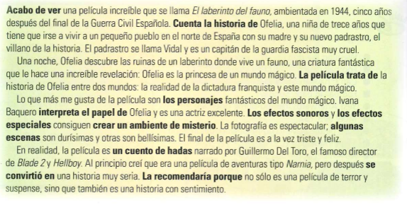¿Demasiado fácil? Traduce el tercero párrafo.

|  |  |
| --- | --- |
| the characters |  |
| the sound effects |  |
| it tells the story of |  |
| the special effects |  |
| create a mysterious atmosphere |  |
| I would recommend it because |  |
| the film deals with |  |
| certain scenes |  |
| acts in the role of |  |
| a fairy tale |  |
| I have just watched |  |
| developed into |  |

1. Lee el texto y escoge las cuatro frases correctas. Explica tu decisión.

a. The thirteen-year-old girl discovers a magic world.  
b. There are four types of monsters in the film.  
c. The film is not about war.  
d. The villain is the cruel stepfather.  
e. There are no special effects in the film.  
f. The film takes place in Spain.  
g. The reviewer did not like the film.

1. ¡Describe la foto!

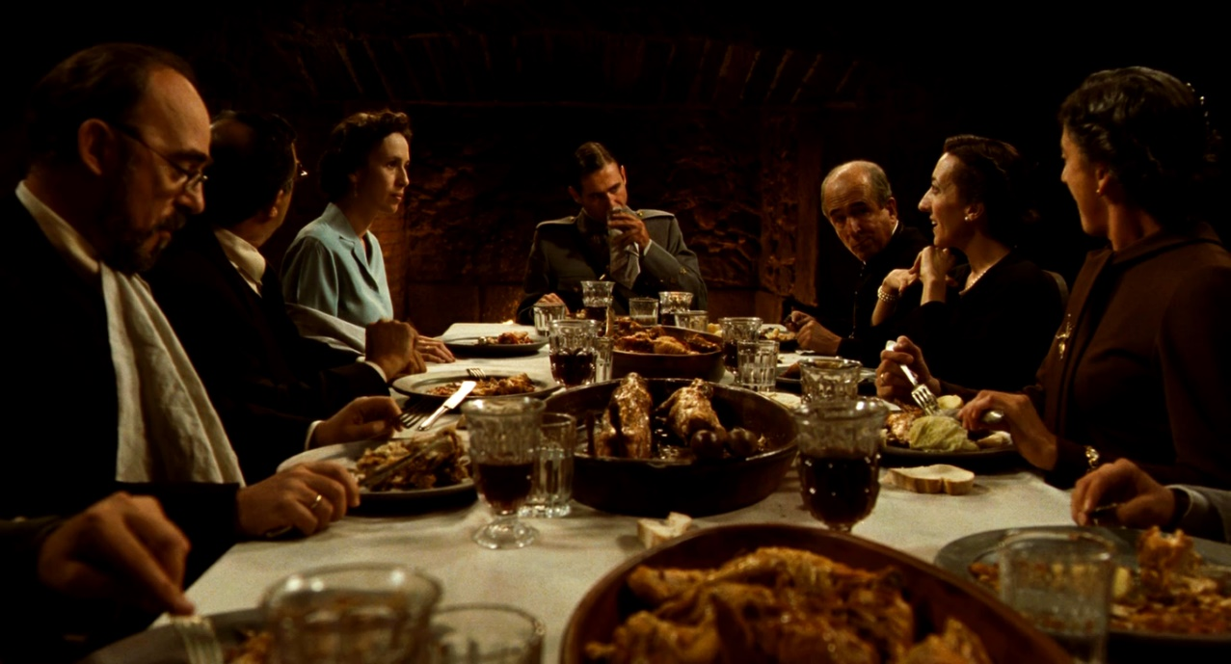

Actividad 6: Los Sitios Web útiles:

Grammar:

[www.spanishdict.com](http://www.spanishdict.com)

[www.languagesonline.org.uk](http://www.languagesonline.org.uk)

News:

[www.rtve.es](http://www.rtve.es)

[www.bbc.com/mundo](http://www.bbc.com/mundo)

www.20minutos.es