Psychology Summer work
Please answer the following questions based on the learning, biological, and the cognitive approach for psychology. You will need to read around these areas in order to complete the following questions.

- “Classical Conditioning” believes that behaviours are learnt through:
- Repetition
- Association
- Reinforcement
- Punishment

- “Operant Conditioning” was researched by:
- Pavlov
- Ainsworth
- Skinner
- Zimbardo

- What was the famous experiment that Albert Bandura carry out for his Social Learning Theory? ______________________________________________________________

______________________________________________________________

- The cognitive approach assumes the brain is most like what?
- An iceberg
- A watch
- A tree
- A computer

- What is genotype?
- A set of genes that people have
- A set of characteristics that people have
- A pair of jeans that people have
- An arrangement of a living organism

- Which two make up the peripheral nervous system?
- The autonomic nervous system
- The automatic nervous system
- The central nervous system
- The somatic nervous system

- What is the mean value of the data set – 5, 7, 7, 9, 10, 11, 12, 14, 15, 17

- Label the missing parts of this diagram of a neuron.

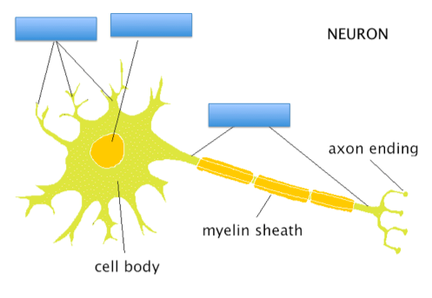

Some useful websites:

- https://www.aqa.org.uk/subjects/psychology/as-and-a-level/psychology-7181-7182
- https://www.simplypsychology.org/
- https://www.psychologytoday.com

