Biology
Bridging
Homework

Essential preparation for A level
Essential bridging work
The following are tasks to prepare you for A-level Biology. There are some essential review tasks and questions and some optional tasks to start extending your knowledge, skills and understanding. This booklet also has an optional reading list at the end.
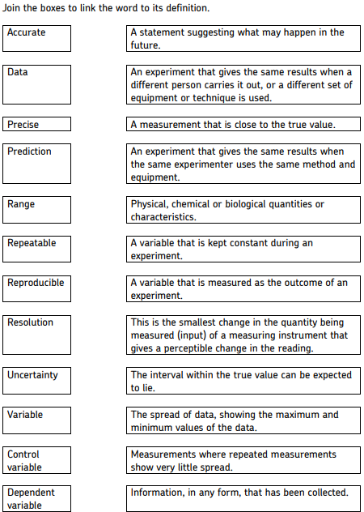
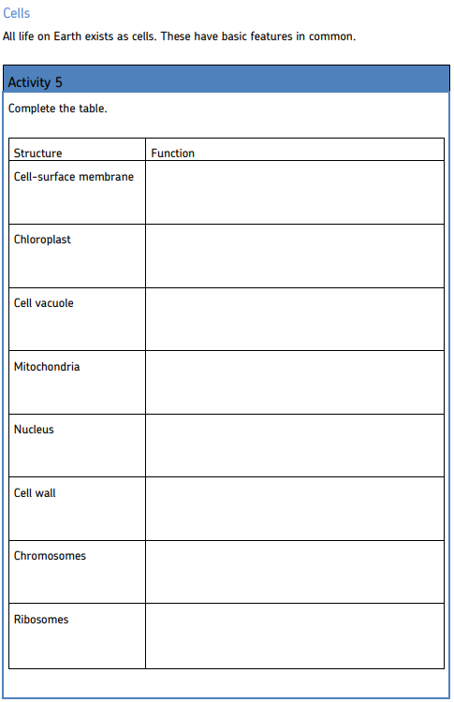
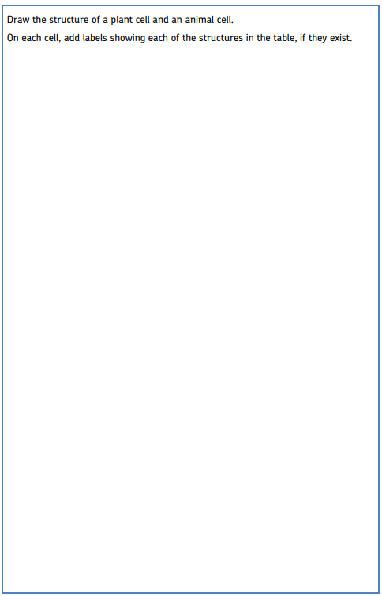
Biological molecules
At GCSE you have learned about some biological molecules.
Please complete the table below.

Name | Components | Examples of  Molecules and  where they are  found | Uses in the body
Proteins
Fats
Carbohydrates
DNA
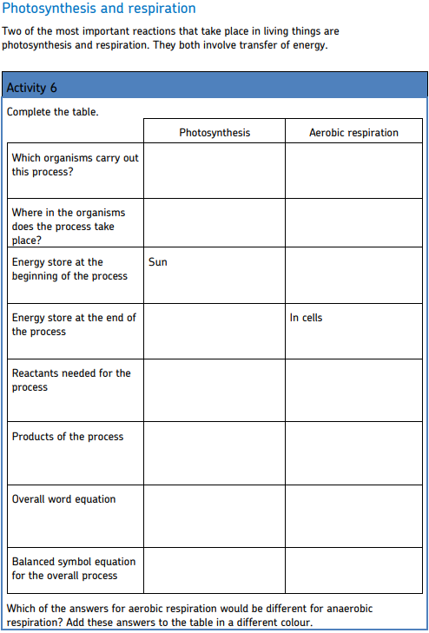
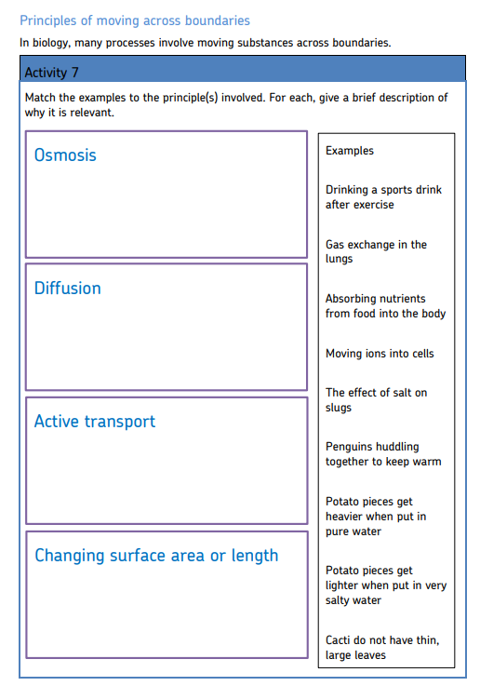

Maths for Biologists

The following are maths skills that you should be confident with for Biology. To support you with this there are some examples to complete for some of skills listed. The following booklet is a useful resources for these tasks: https://www.ocr.org.uk/Images/294471-biology-mathematical-skills-handbook.pdf

Maths skills
- Converting units e.g. mm to cm, or mm3 to cm³
- Use of standard form e.g. 5.0 x 10-3
- Calculating percentage, or percentage change
- Use of fractions and ratios
- State an answer to a number of significant figures
- State an answer to a number of decimal places
- Calculating mean
- Drawing a charts
- Know the meaning of all these Maths symbols: = < << >> > ∝ ~ -
- Re-arranging equations - Understand the formula for a linear relationship y=mx+c
- Calculating rate from the straight line of a graph
- Using the slope of a tangent to a curve to measure rate of change
- Calculating circumference, surface area and volume of a circle/sphere
- Calculating circumference, surface area and volume of a rectangular prism

Standard Prefixes
Prefixes are used to modify units. Prefixes that are commonly used are listed below - you are most likely to be asked to convert between the ones highlighted:
Prefix Symbol Multiplier Example
mega M x10⁶ (or x 1,000,000) Mb (megabyte)

kilo K x10³ (or x 1,000) kJ (kiloJoule)

no prefix - x10° (or x 1) N (Newton)

deci d x10⁻¹ (or x 0.1) dm³ (cubic decimetre or litre)

centi c x10⁻² (or x 0.01) cm (centimetre)

milli m x10⁻³ (or x 0.001) mg (milligram)

micro µ x10 ⁻⁶ (or x 0.000001) µm (micrometre)

nano n x 10⁻⁹ (or x 0.000000001) nm (nanometre)

pico p x10⁻¹² ( or x 0.000000000001) pg (picogram)

For example:
1m= 1000mm 1mm = 1000μm 1 μm = 1000nm
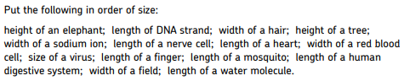
Starter task

Read about unit conversions the complete the headings and conversions in the table below:
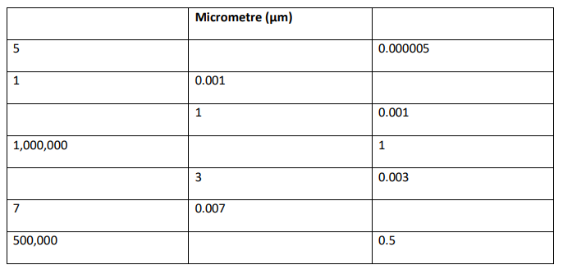
Standard Form
Numbers with many zeros can be difficult to follow, so we express these in standard form – it acts as a kind of numerical abbreviation.
Example:
The herpes virus has 156,000 bases in its DNA.
So how do we express the number 156,000 in standard form?
- Find the decimal point: 156,000.0
- Move the decimal point to give a number between 1 and 10: 1.56000
- Multiply the number by 10 raised to the power x
- x is the number of jumps that you made to the left

Answer = 1.56 ×10⁵

Sometimes the decimal point may move the other way.
Example:
The blood protein IgE is connected with allergic reactions. Its concentration in the blood is about 0.000012 grams per 100cm³:
- Find the decimal point and move it to give a number between 1 and 10.
- This time it goes to the right: 000001.2
- Multiply the number by 10 raised the power x
- x is the number of jumps you made
- This time the index will be negative.

In standard form, the concentration is 1.2 ×10^{–5} grams per 100cm³.

Standard Form Questions

1) Write down the following measures in standard form:

- 2560
- 30000
- 450
- 5678
- 45310
- 6789010
- 2678991
- 0.000569
- 0.00018
- 0.000000486
- 0.21
- 0.365
- 0.0047
- 0.1

- 750 g
- 500 ml
- 0.275 J
- 0.0095 N
- 10,000 KJ
- 0.0033 mm

Ratios, Fractions and Percentages
A ratio is a way of comparing the magnitudes of two (or more) quantities. You can only give a ratio when the units of each quantity are the same, so when working with a ratio involving different units, always change them to the same unit. The ratio itself does not have any units. For example, the ratio of 125 g to 2 kg must be changed to 2000 g, so that it can be given as 125:2000.
- Divide both sides by 125, giving 1:16, the simplest form of the ratio.

Ratios can be used to calculate other quantities,
You can take a ratio in its simplest form and express the amount of each part of the ratio as a fraction. Each will have the same common denominator.

Example:

A field is sown with two different types of seed in the ratio 3:2. Seed x makes up 3/5 of the contents of the field, and seed y makes up 2/5 of the contents of the field. The common denominator (5) comes from adding the numbers in the ratio (3+2)
Ratios can also be expressed as percentages. In the above example, seed x takes up 60% (3/5×100) of the field, and seed y 40%.

Percentage Change
Method
% change = final value - original value x 100
original value

Percentage Change Questions:
2) A piece of potato, weighing 3g increases in mass to 7g when placed in a sucrose solution. What is its percentage change?

3) Another piece of potato increases from 4g to 5g - what is its percentage increase?

4) Another piece of potato loses mass as it changes from 6 g to 5.5g, what is its percentage change?

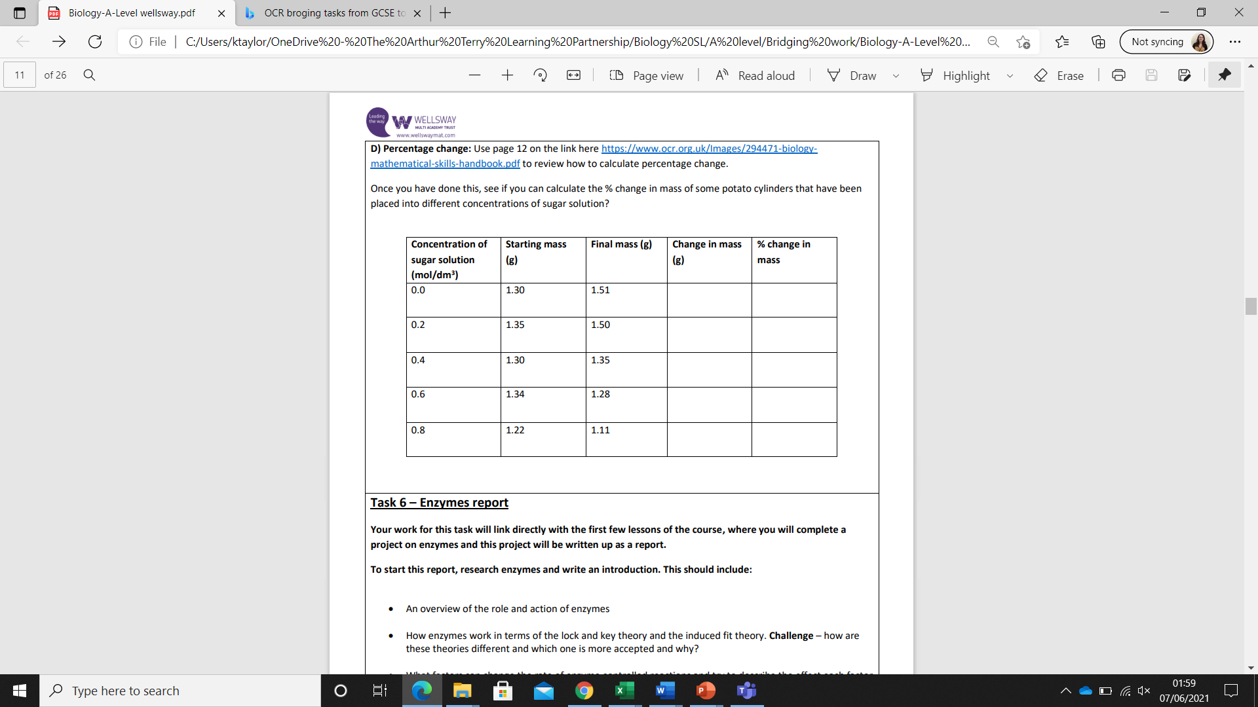

Magnification
REMEMBER:
Actual Size = Image size
Magnification

so Magnification = Image size
Actual size
(AND Image size = Actual size x Magnification)

The triangle below can be useful – cover up the required value

I

A M

E.g.
- To calculate I = M x A
- To calculate M = I/A
- To calculate A = I/M

All measurements must be in the same units i.e. 22mm and 0.002mm

To convert mm to μm x1000

To convert μm to mm divide by 1000

Microscope Questions
5) An image with a magnification of x50 shows an ant’s head to be 40mm long. Calculate the actual length in μm.

6) A photograph shows the width of a human egg to be 700mm. Its actual size is 0.1 mm. What is the magnification?

7) A cell measures 20mm - what is the image's magnification if the cell is actually 500μm in length?

Mean Averages
In biology practical work, we often quote an ‘average value’. The correct term for this type of average value is the mean. The arithmetic mean is given by the equation:
x = Σx
n

Σx means the sum of all the x values.
The mean of 8, 5, 3, 8, 7, 5, 7 = 8 + 5 + 3 + 8 + 7 + 5 + 7 = 7
7
Question
8) Four students weigh 70kg, 65kg, 80kg and 55kg - what is their mean body mass?

Surface area to volume ratio
Look up how to calculate the surface area and volume of a sphere then compere question 9 below:
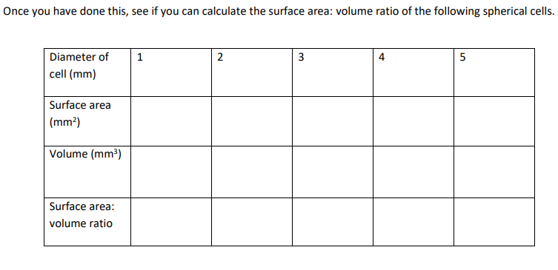

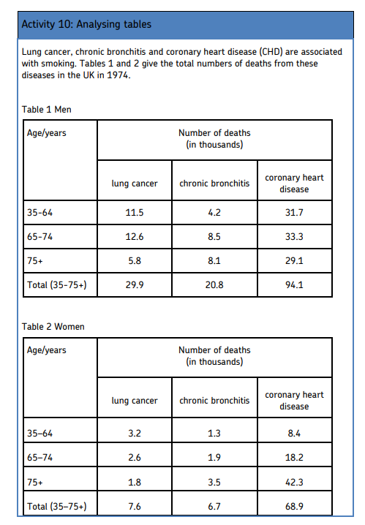
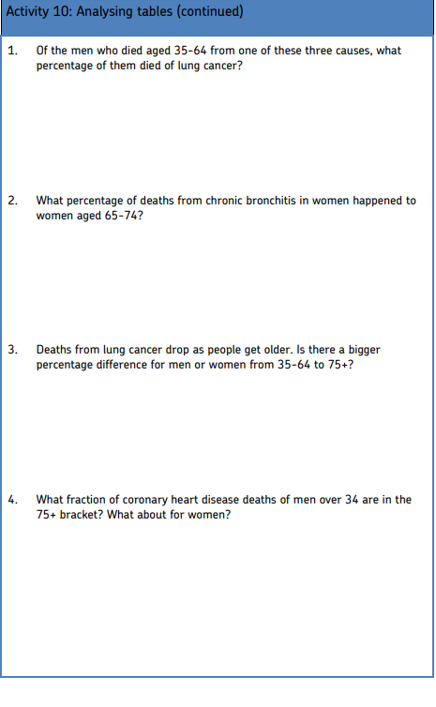
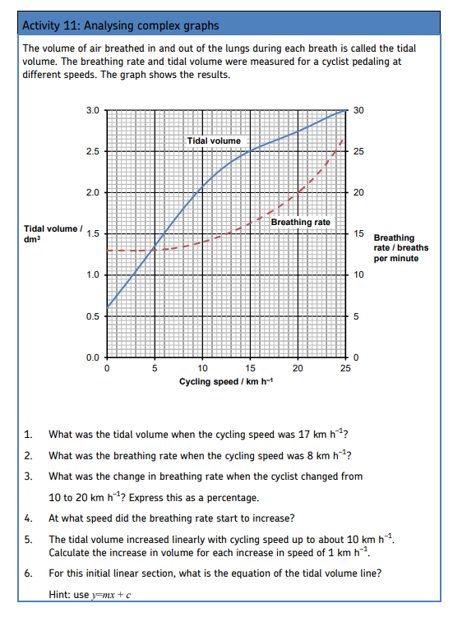
Biological drawing
Have a go at drawing a labelling the following image of the transverse section of a leaf below. Review your work on leaf structure from GCSE as this will help you. Please include labels.

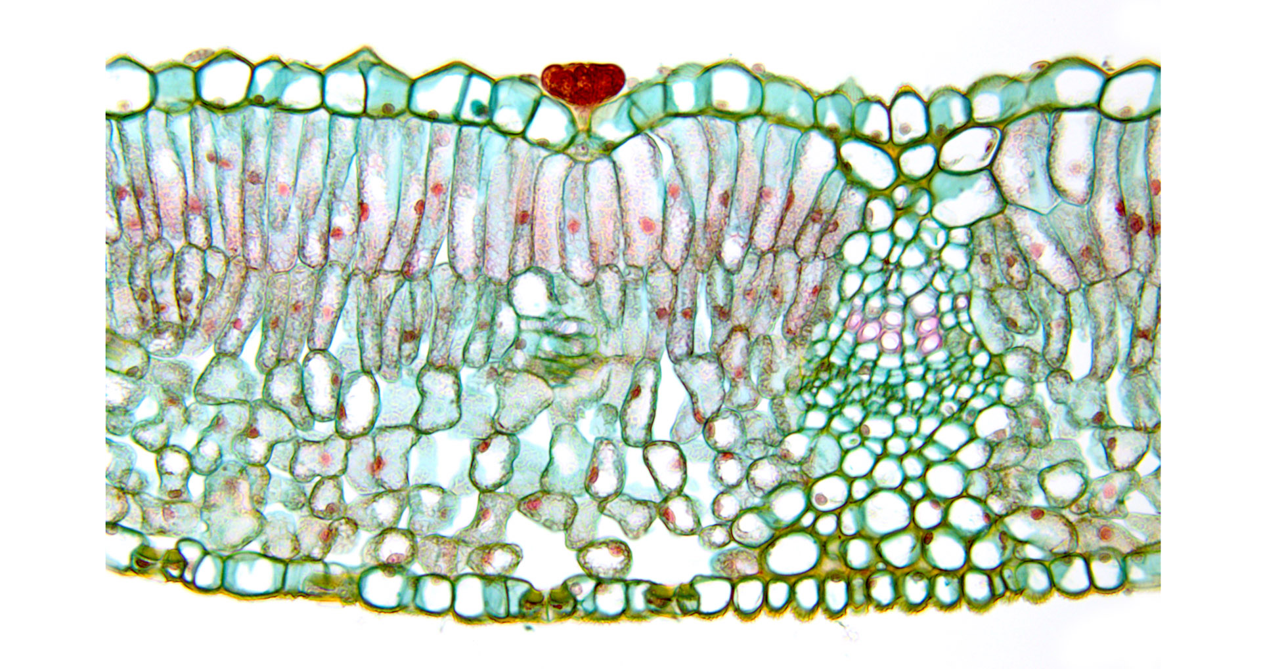

Exam style questions
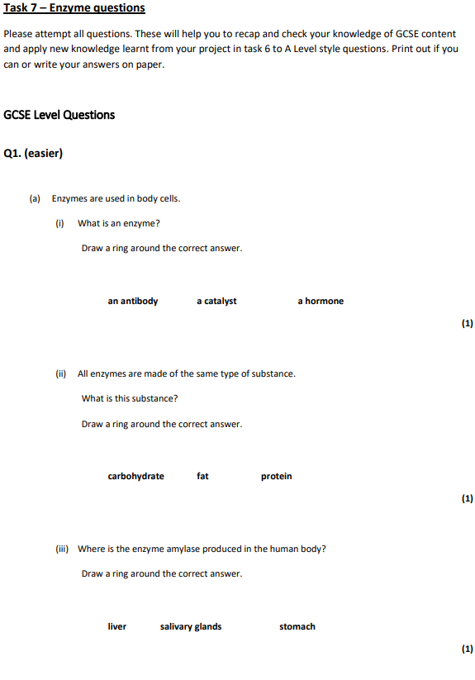
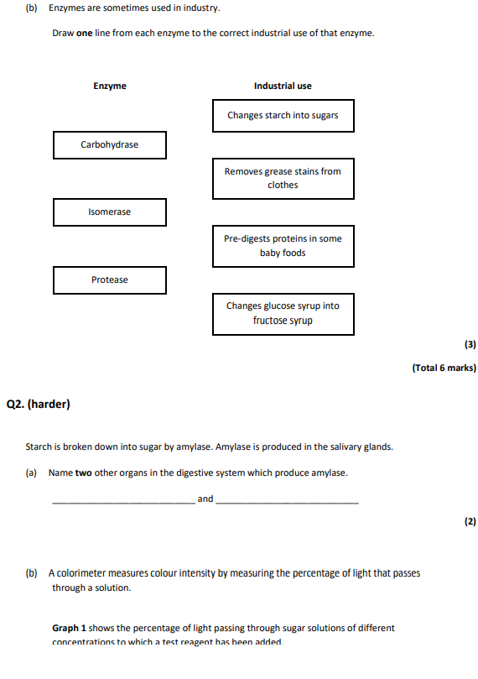
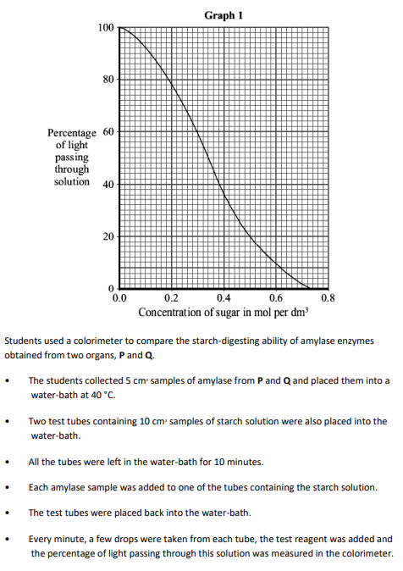
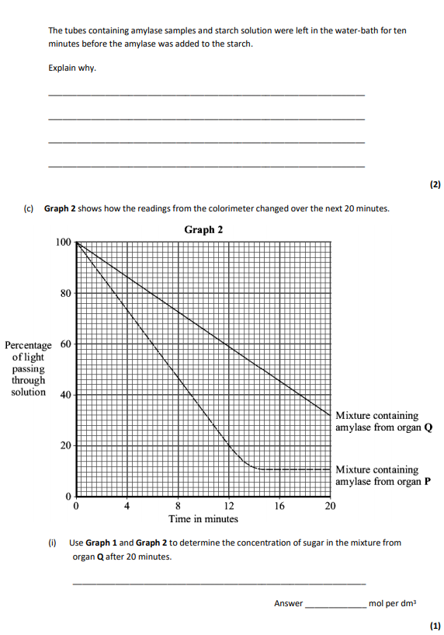
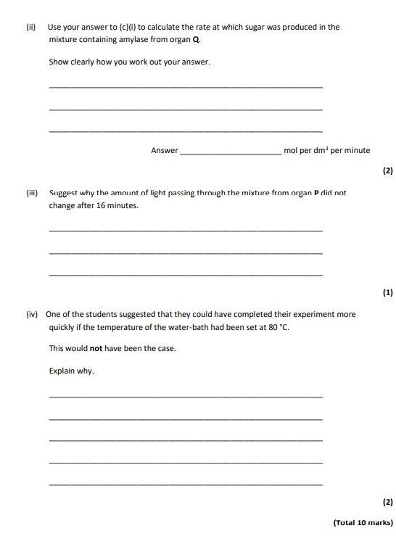

Bridging questions (some A level content!)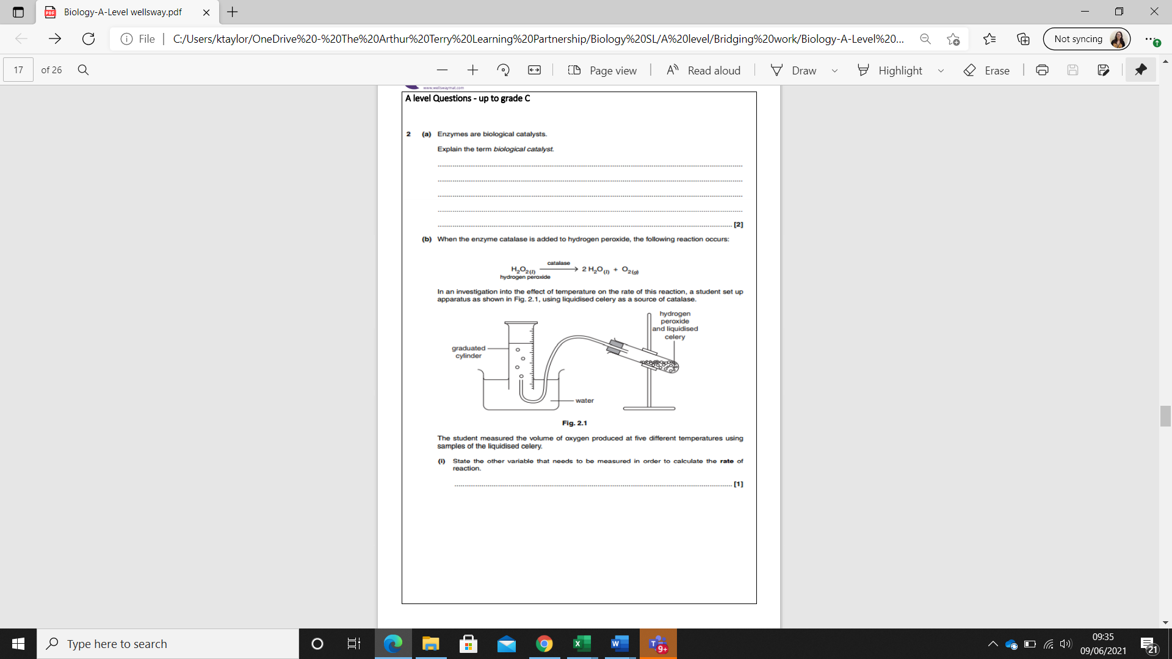
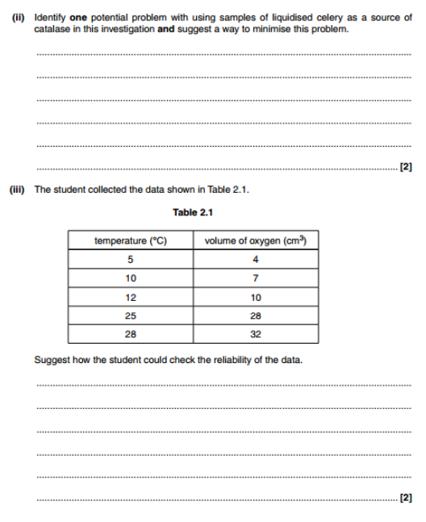

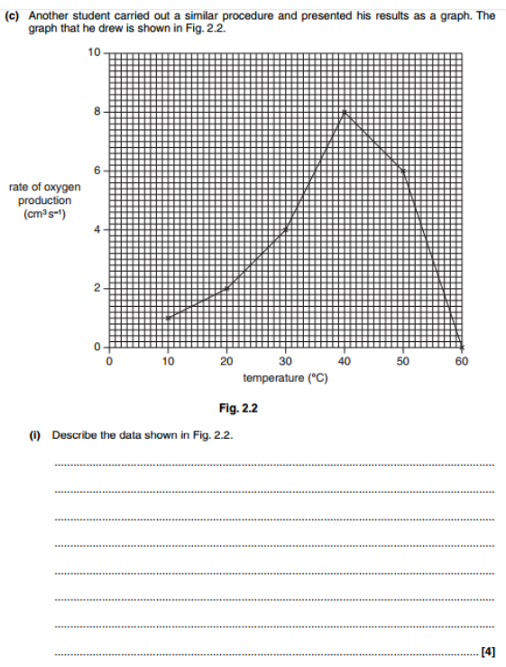

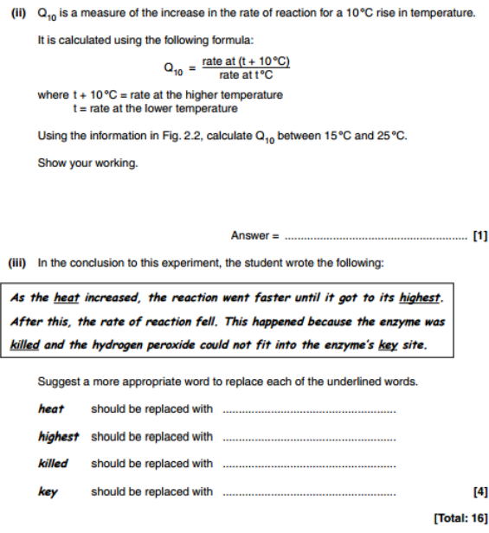

Additional materials, optional bridging tasks and information
Optional- Revision topics
The entry requirements of the course are grade 6 in Science Trilogy or Separate science biology GCSE. There are topics covered by the separate sciences course which are useful but not essential for study at A level. However, if you have some time then familiarising yourself with the material would be useful. The sections in bold should be prioritised.
Topic | Lesson | Oak lesson links
Unit 1 | Culturing microorganisms | https://classroom.thenational.academy/lessons/aseptic-techniques-c9jkjd
 | Effectiveness of disinfectants | https://classroom.thenational.academy/lessons/effectiveness-of-disinfectants-c4r34c
Unit 3 infection and organisation | Monoclonal antibodies | https://classroom.thenational.academy/lessons/monoclonal-antibodies-6djp2t
 | Plant diseases | https://classroom.thenational.academy/lessons/plant-diseases-and-deficiencies-part-1-61jpcd  https://classroom.thenational.academy/lessons/plant-diseases-and-deficiencies-part-2-cnjp6r
 | Review | https://classroom.thenational.academy/lessons/review-bio-only-6ngpae
Unit 5 Homeostasis and response | The brain | https://classroom.thenational.academy/lessons/the-brain-64rk4c
 | The eye | https://classroom.thenational.academy/lessons/the-eye-61h64e  https://classroom.thenational.academy/lessons/correcting-vision-68w3at
 | Control of body temperature | https://classroom.thenational.academy/lessons/regulating-body-temperature-68v38e
 | Maintaining water and nitrogen balance in the body, kidney failure and review | https://classroom.thenational.academy/lessons/the-kidney-6ww3ct  https://classroom.thenational.academy/lessons/kidney-failure-69gpct  https://classroom.thenational.academy/lessons/water-balance-6cu3ec  https://classroom.thenational.academy/lessons/osmoregulation-review-6mt36t
 | Plant hormones | https://classroom.thenational.academy/lessons/required-practical-plant-hormones-part-1-cgrkje  https://classroom.thenational.academy/lessons/required-practical-plant-hormones-part-2-6mu3ct
Unit 6 Inheritance, variation and evolution | Advantages and disadvantages of sexual and asexual reproduction | https://classroom.thenational.academy/lessons/advantages-and-disadvantages-of-sexual-and-asexual-reproduction-60w6ce
 | Protein synthesis | https://classroom.thenational.academy/lessons/protein-synthesis-68w62c
 | Cloning | https://classroom.thenational.academy/lessons/cloning-crrked
 | Speciation | https://classroom.thenational.academy/lessons/speciation-6rtkad
 | Understanding of genetics- Mendel | https://classroom.thenational.academy/lessons/mendel-cnhpar
 | Review | https://classroom.thenational.academy/lessons/end-of-topic-review-part-2-6mt38c
Unit 7 Ecology | Decomposition | https://classroom.thenational.academy/lessons/decay-6crkjd  https://classroom.thenational.academy/lessons/decay-required-practical-cdj30c
 | Impact of environmental change review | https://classroom.thenational.academy/lessons/review-part-3-cnj36d
 | Trophic levels in an ecosystem | https://classroom.thenational.academy/lessons/biomass-64rpcc
 | Food production | https://classroom.thenational.academy/lessons/food-security-and-farming-6mw3gr

Note taking
Producing ‘Cornell Notes’ is a very effective way to summarise your notes and any reading that you might do.
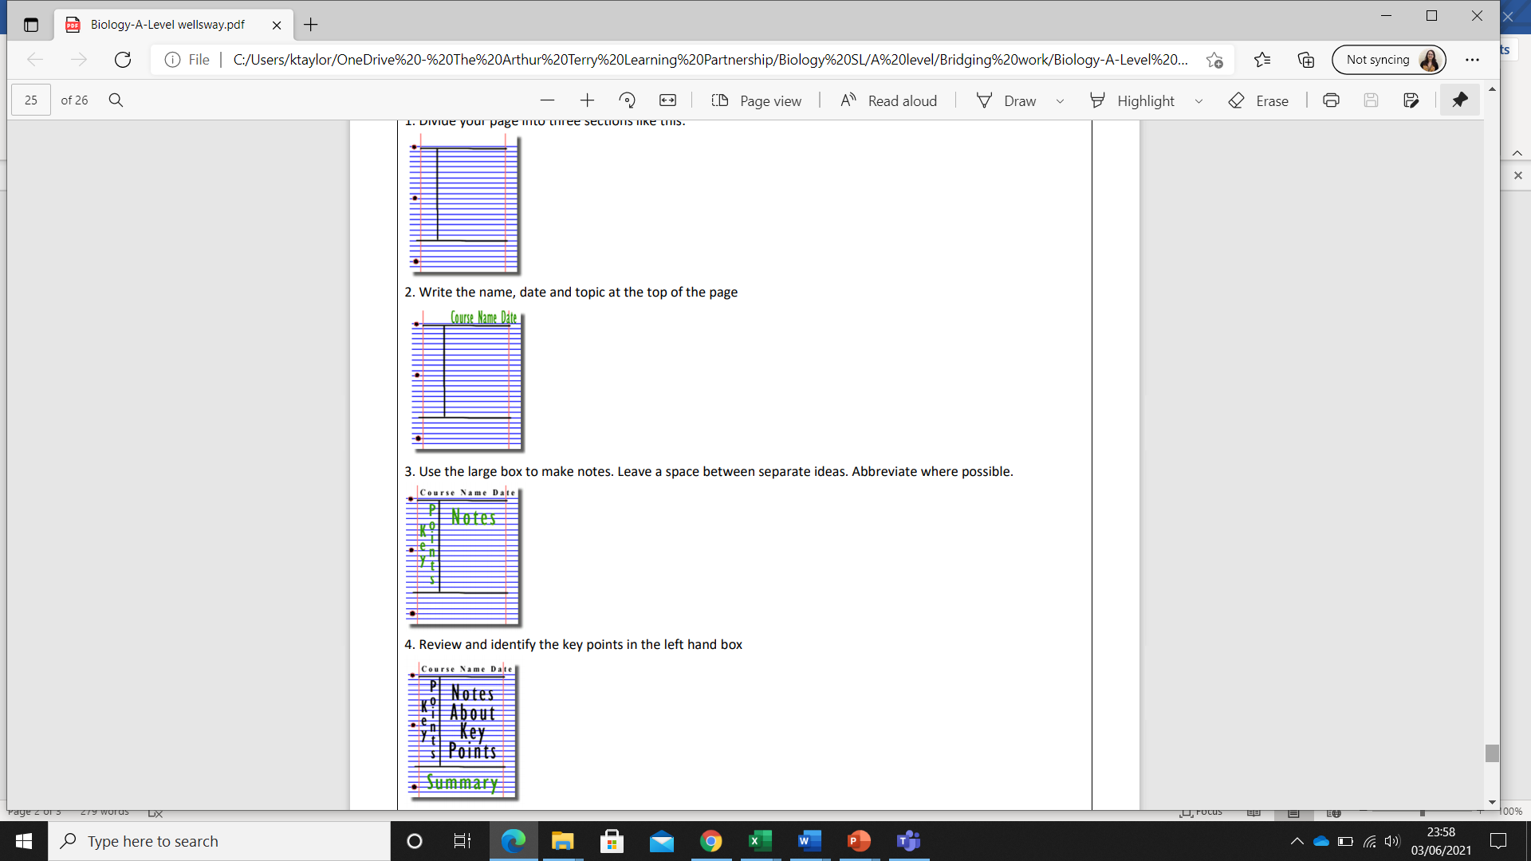
How to produce Cornell Notes:
1. Divide your page into three sections like this

2. Write the teacher initials in the margin and the specification reference, then the title and date at the top of the page
3. Use the large box to make notes. Leave a space between separate ideas. Abbreviate where possible. We will help you with this.
4. Review and identify the key points in the left hand box if these have not been provided to you and make a list of any new terminology.

After the lesson:
5. Write a five line summary of the main ideas in the bottom space

Optional reading
If you would like to explore biology a little more then the following might be interesting reads. Remember that libraries are open for loan requests so there is no need to buy these and many are available online:
Journals:
Biological sciences
Books:
Emily Anthes: Frankensteins’s cat
Bill Bryson: A Short History of Nearly Everything
Nessa Carey: Junk DNA
Charles Darwin: The origin of species
Alice Roberts: The Incredible Unlikeliness of Being: Evolution and the Making of Us’,
Matt Ridley: The Red Queen: Sex and the Evolution of Human Nature.
Short films/series:
Any of the BBC David Attenborough documentaries including Blue planet

